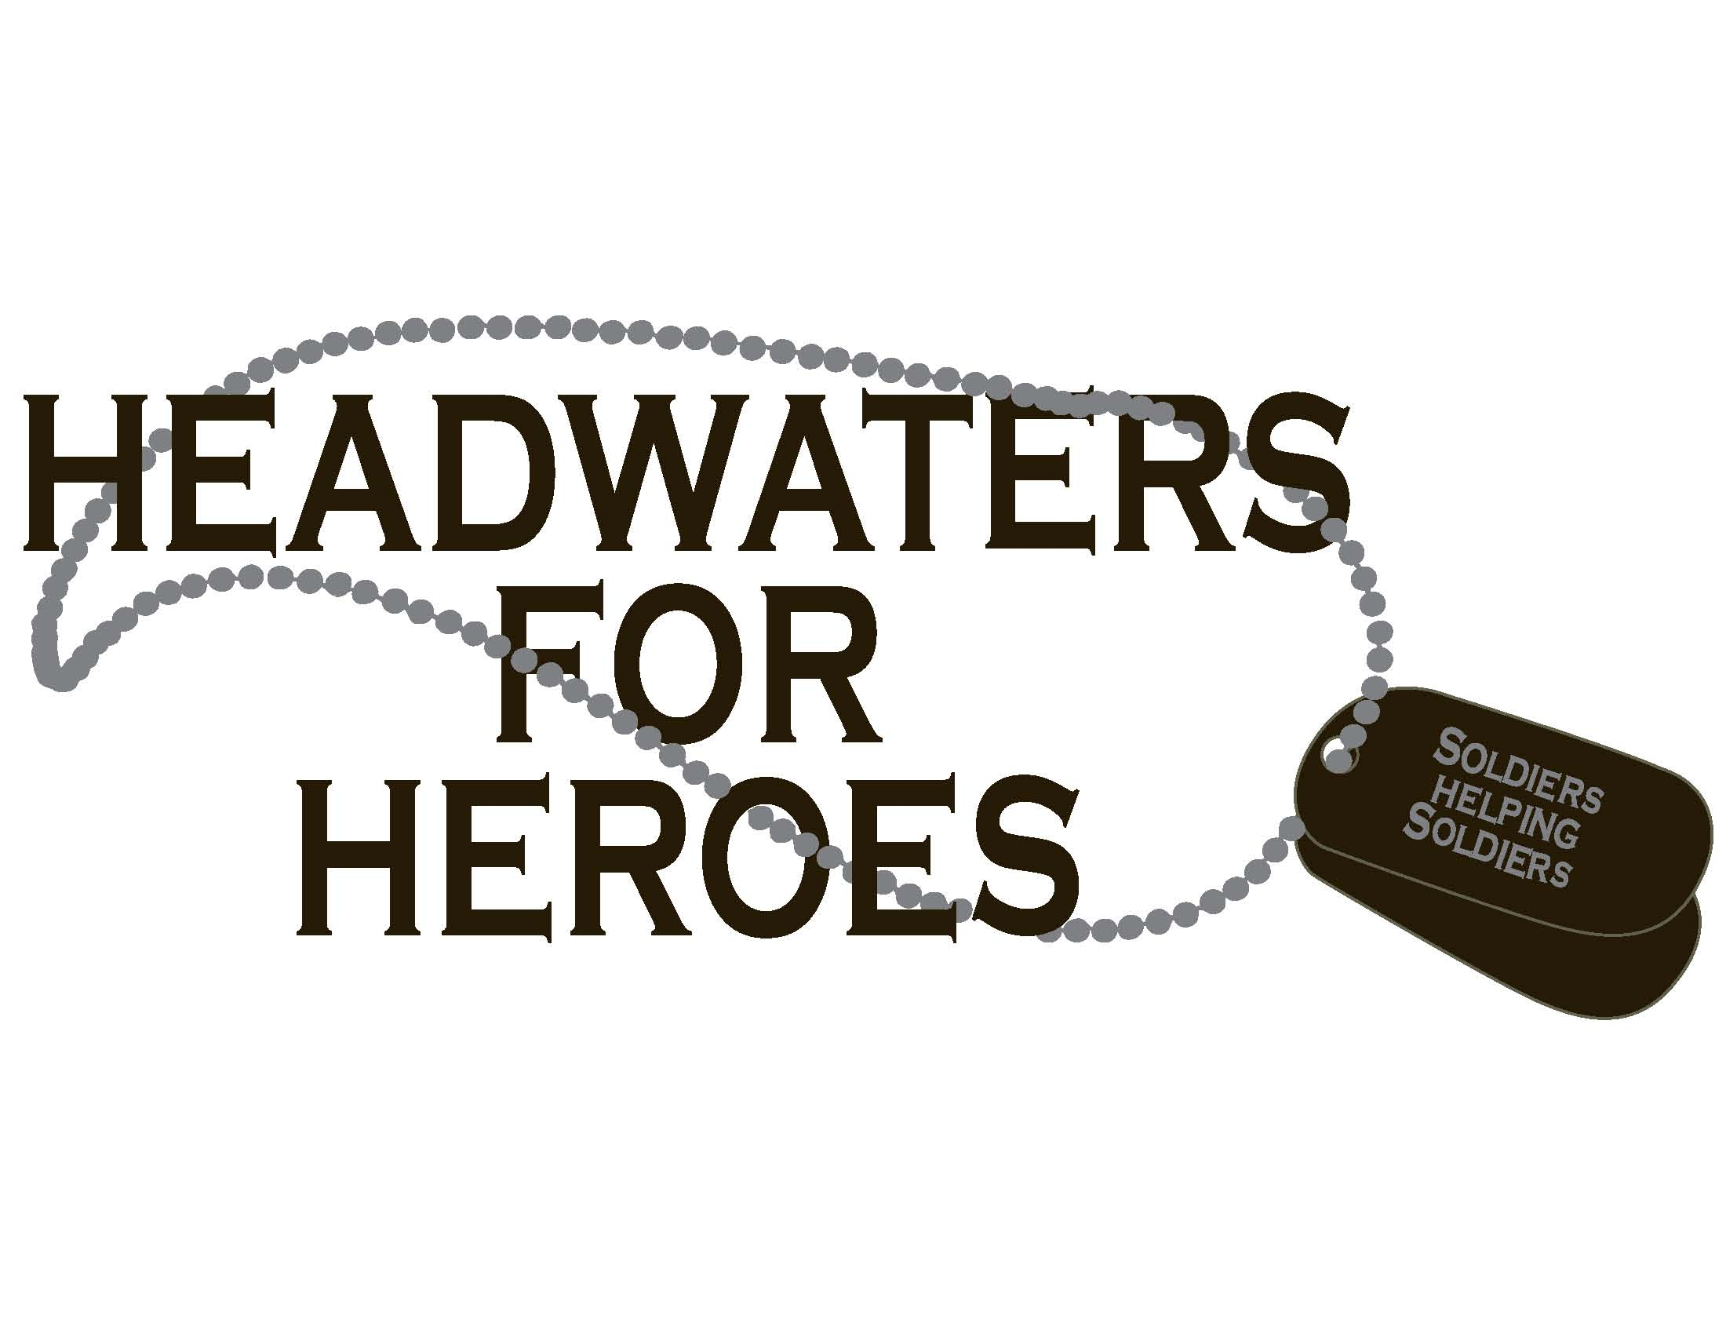

Registration for sporting clay event 10:30

Shooting starts at 1pm

BBQ Dinner 4pm

Auction begins 5:30pm

Music by Jeff Smithart 9pm

Sponsor Information (please print)

Name

Billing address

City, ST Zip Code

Phone 1 | Phone 2

Email

Sponsorship
Sponsorship amount: $_______________
☐ Donation Sponsor $250 (Name on Banner, 2 Meal Tickets)
☐ Station Sponsor $500 (Team of 4, Banner at Station, 4 Meal Tickets, Name on T-shirts, and 4 T-shirts) 10 available
☐ Banner Sponsor $500 ( Name on Banner, 6 Meal Tickets, Name on T-shirts, 5 T-shirts)
☐ Event Sponsor $2500 ( Big Banner, Name on T-Shirts, 10 Meal tickets, 4 T-Shirts, Name mentioned on radio ads)

All Logo's for banners and T-Shirts must be submitted to exotic_tees@yahoo.com No later than April 1, or only a name will be listed.
I (we) plan to make this contribution in the form of: ☐cash ☐check
Signature ____________________________________ |  | Date _____________________________
Please make checks, corporate matches,  or other gifts payable to:  Headwaters for Heroes MOPH #814 |  | Headwaters for Heroes  P.O box 336  Harper, Texas, 78631

Please fax to 830-864-5260, or email to exotic_tees@yahoo.com.

