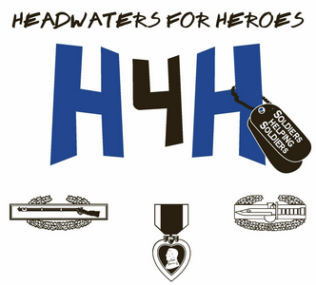
5th Annual Headwaters for Heroes Lake LBJ Fishing Tournament
October 7th , 8th, 9th, 2016
Longhorn Resort on Lake LBJ
151 Melodie Lane
Kingsland, Texas 78639
Participants will fish with experienced fishing guides, so no need to be a “Master Angler”. Bow fishing nightly, entertainment for the whole family daily.
So come enjoy good fishing, good fellowship, good food, good music, and more.
This event is open to the Combat Wounded (both veteran and active), Gold Star families, and multiple deployment soldiers.
To sign up go to www.headwatersforheroes.com and click on the fishing tournament tab and fill in the form. Due to limited spaces the Combat Wounded will receive first chance followed by the Gold Star Families, then the Multiple Deployment Soldiers.
For Information Contact:
Larry Hawkins
254-317-0853
archerysoldier1@yahoo.com
James Spivey
903-288-7006
devil_dawg.0311@yahoo.com
Steven Sweeney
830-992-1193
stevensweeney59@gmail.com

