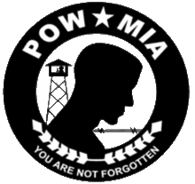

POW MIA CEREMONY

Guest Speaker
Cam King

“Target Berlin: the Story of 1st Lt. Frank L. King, Jr.
B-17G Bomber Pilot, 8th Air Force”

When and Where
Friday September 16th 10:30 am
(Refreshments following program)
VFW Post 7105, 710 S. Washington St., Fredericksburg
(Non-Smoking event)

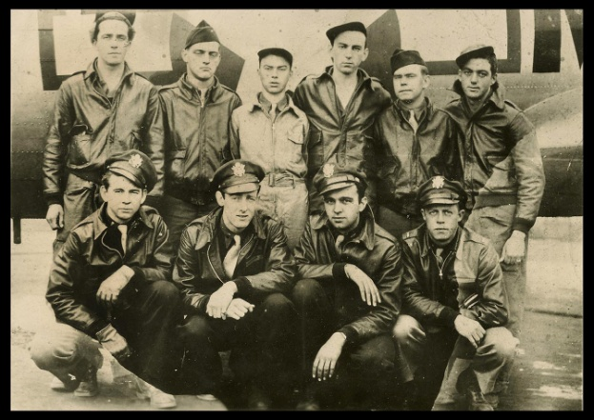

Sponsored by: VFW Post 7105
and the Veterans Council of Gillespie County

PLEASE RSVP by Wednesday Sept 14th.
For RSVPs and requests for additional information, please contact
Tami King at the Gillespie County Veterans Service Office 830-997-3758.

